Dear Parents,

We had a fabulous day at Russell Farm! A special thank you to all of our chaperones.

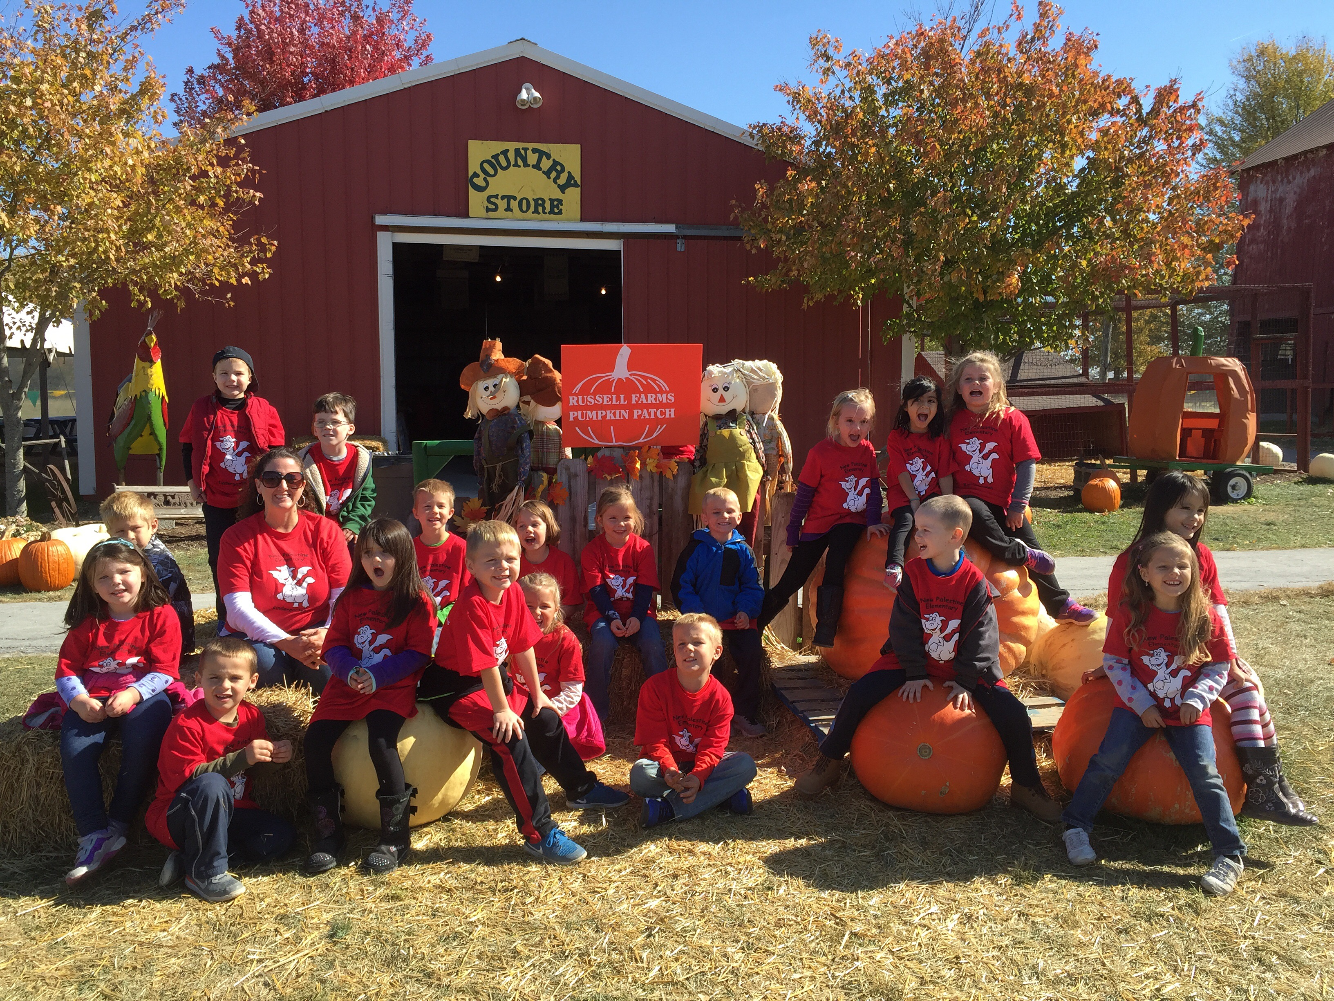

Have a great weekend!

Mrs. Tiede-White

*****What’s Next ???***

**Theme** **of the Week:** Review / Fall

Review Letter Pp

**Language Arts Skills**: printing our names, concepts of print, nouns, plural nouns, verbs, periods and question marks

**Kinder Core Words: we, my, like**

**Math Skills**: Counting, Shapes & patterns

**Monday (10-26**) –

**Tuesday (10-27)** – Unified Arts

**Wednesday (10-28)** –

**Thursday (10-29)** – Unified Arts

**Friday (10-30)** – Fall Party (see second column)

*Save for us…..*

*We recycle coffee cans and oatmeal containers.*

Instagram:

Find us at: twkindercorner

**MC900441398[1]Donation Den:**

**Snacks for those without.**

UNIFIED ARTS and RECESS:

Please be sure your child wears or brings tennis shoes everyday!

Remember to dress for the weather: jackets, hats and mittens

**MC900413444[1]Science Center**

**Your child may bring an insect to school to share!**

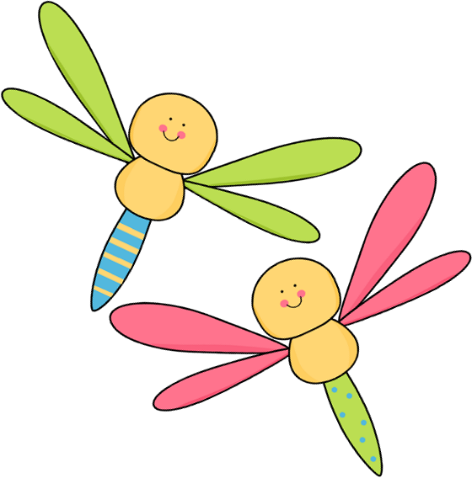

Important Date:

* Grandparent Breakfast November 9

Make it a healthy habit to check your child’s head for lice on a regular basis. ☺

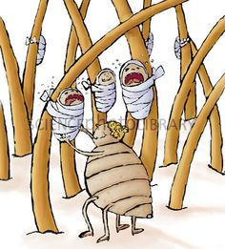

Halloween

Halloween is a big deal at NPE!  On Friday, October 30th, students will put their abbreviated costumes on over their school clothes at 2:00.  The parade is at 2:15.  We will do the parade in the building as we did last year.  Parents who are setting up for the party can come into the room at 2:00.

Please tell students that face or hair paint and weapons are not allowed.  Also, their costume should not scare a preschool student or Mrs. Tiede-White.  Please let me know if you have any questions. ☺

**October Birthdays**

Grace Thomas-2

Ben Edwards-2

Lucas Lester-23



Birthday Note:

If your child would like to celebrate his/her birthday

school, let me know and we can plan a day for your child to bring in birthday treats. Treats need to be store purchased.