iPad Café Session 2
iOS 7
2014

Annotate and Grade on iPad

Review Can you…
Create a new folder?
Find the Class Dojo app using Spotlight?
Take a Screenshot?
Access the control center and find AirPlay?

1. Join our Showbie Class called iPad Cafe
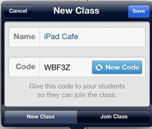

2. Find your “Certificate Assignment.” This is where you will be turning in your assignment from Notability.

3. Open Up Notability, DocAS, or Adobe (free)
Take a picture within the app.
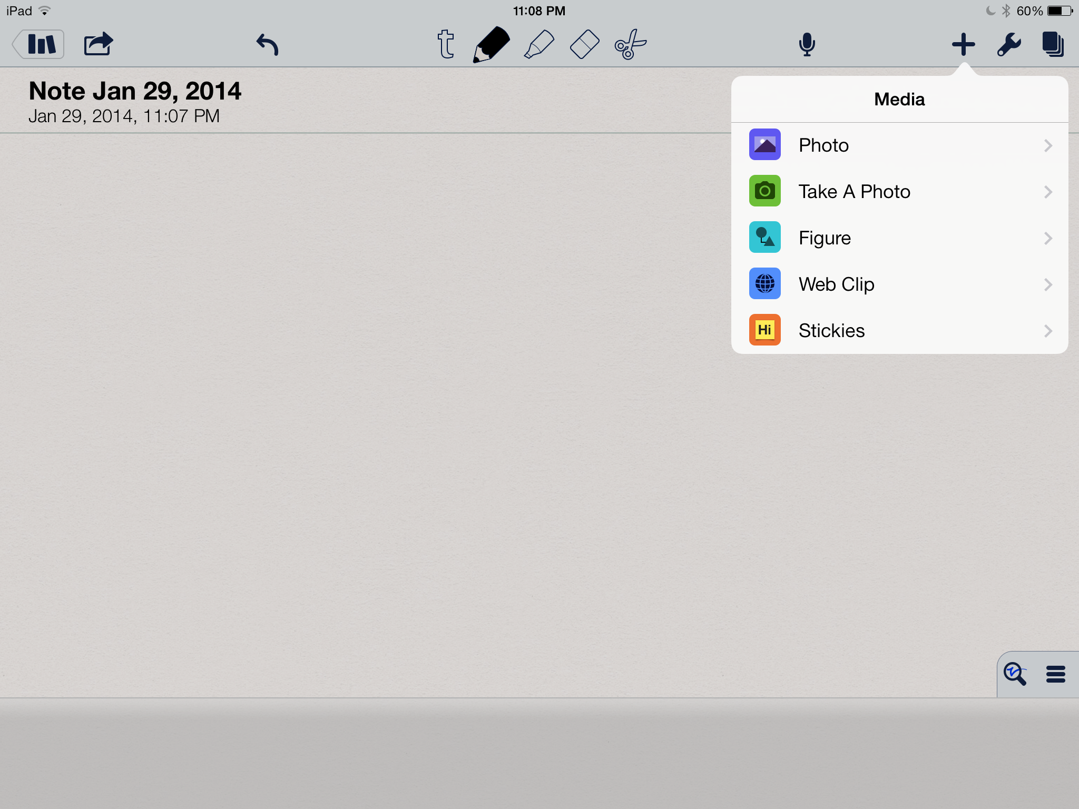

4. Write on it and save.
5. Open it in in the Showbie it app.
6. Turn it in to your Class

7. Download a PDF from the Internet using your Safari icon. Pick a worksheet from http://www.worksheetworks.com/ Touch in the middle of the screen and choose “Open In” to write on it in another application.
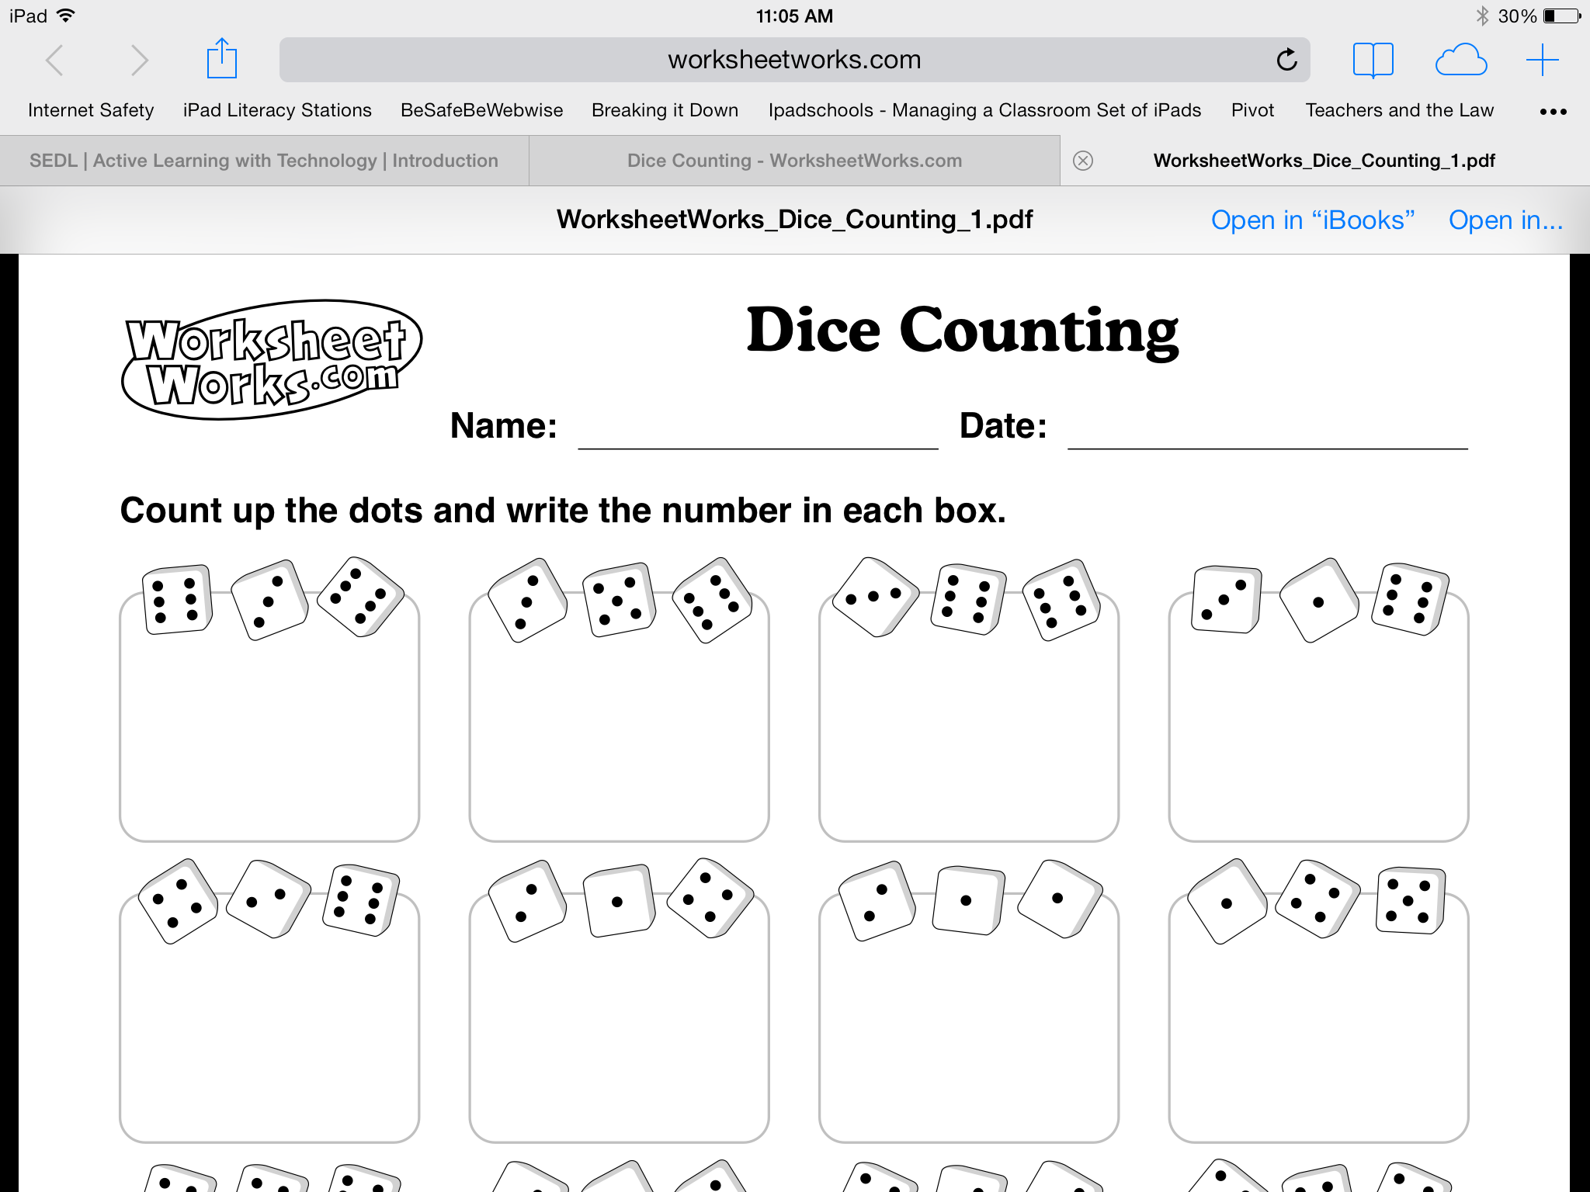
8. When you have finished writing, choose your destination in order to send this document to another application. This is a great way to be able to turn it in to your class Showbie It folder if you are signed in as a student. Other applications and even email will allow you to send documents back and forth to create a paperless classroom.

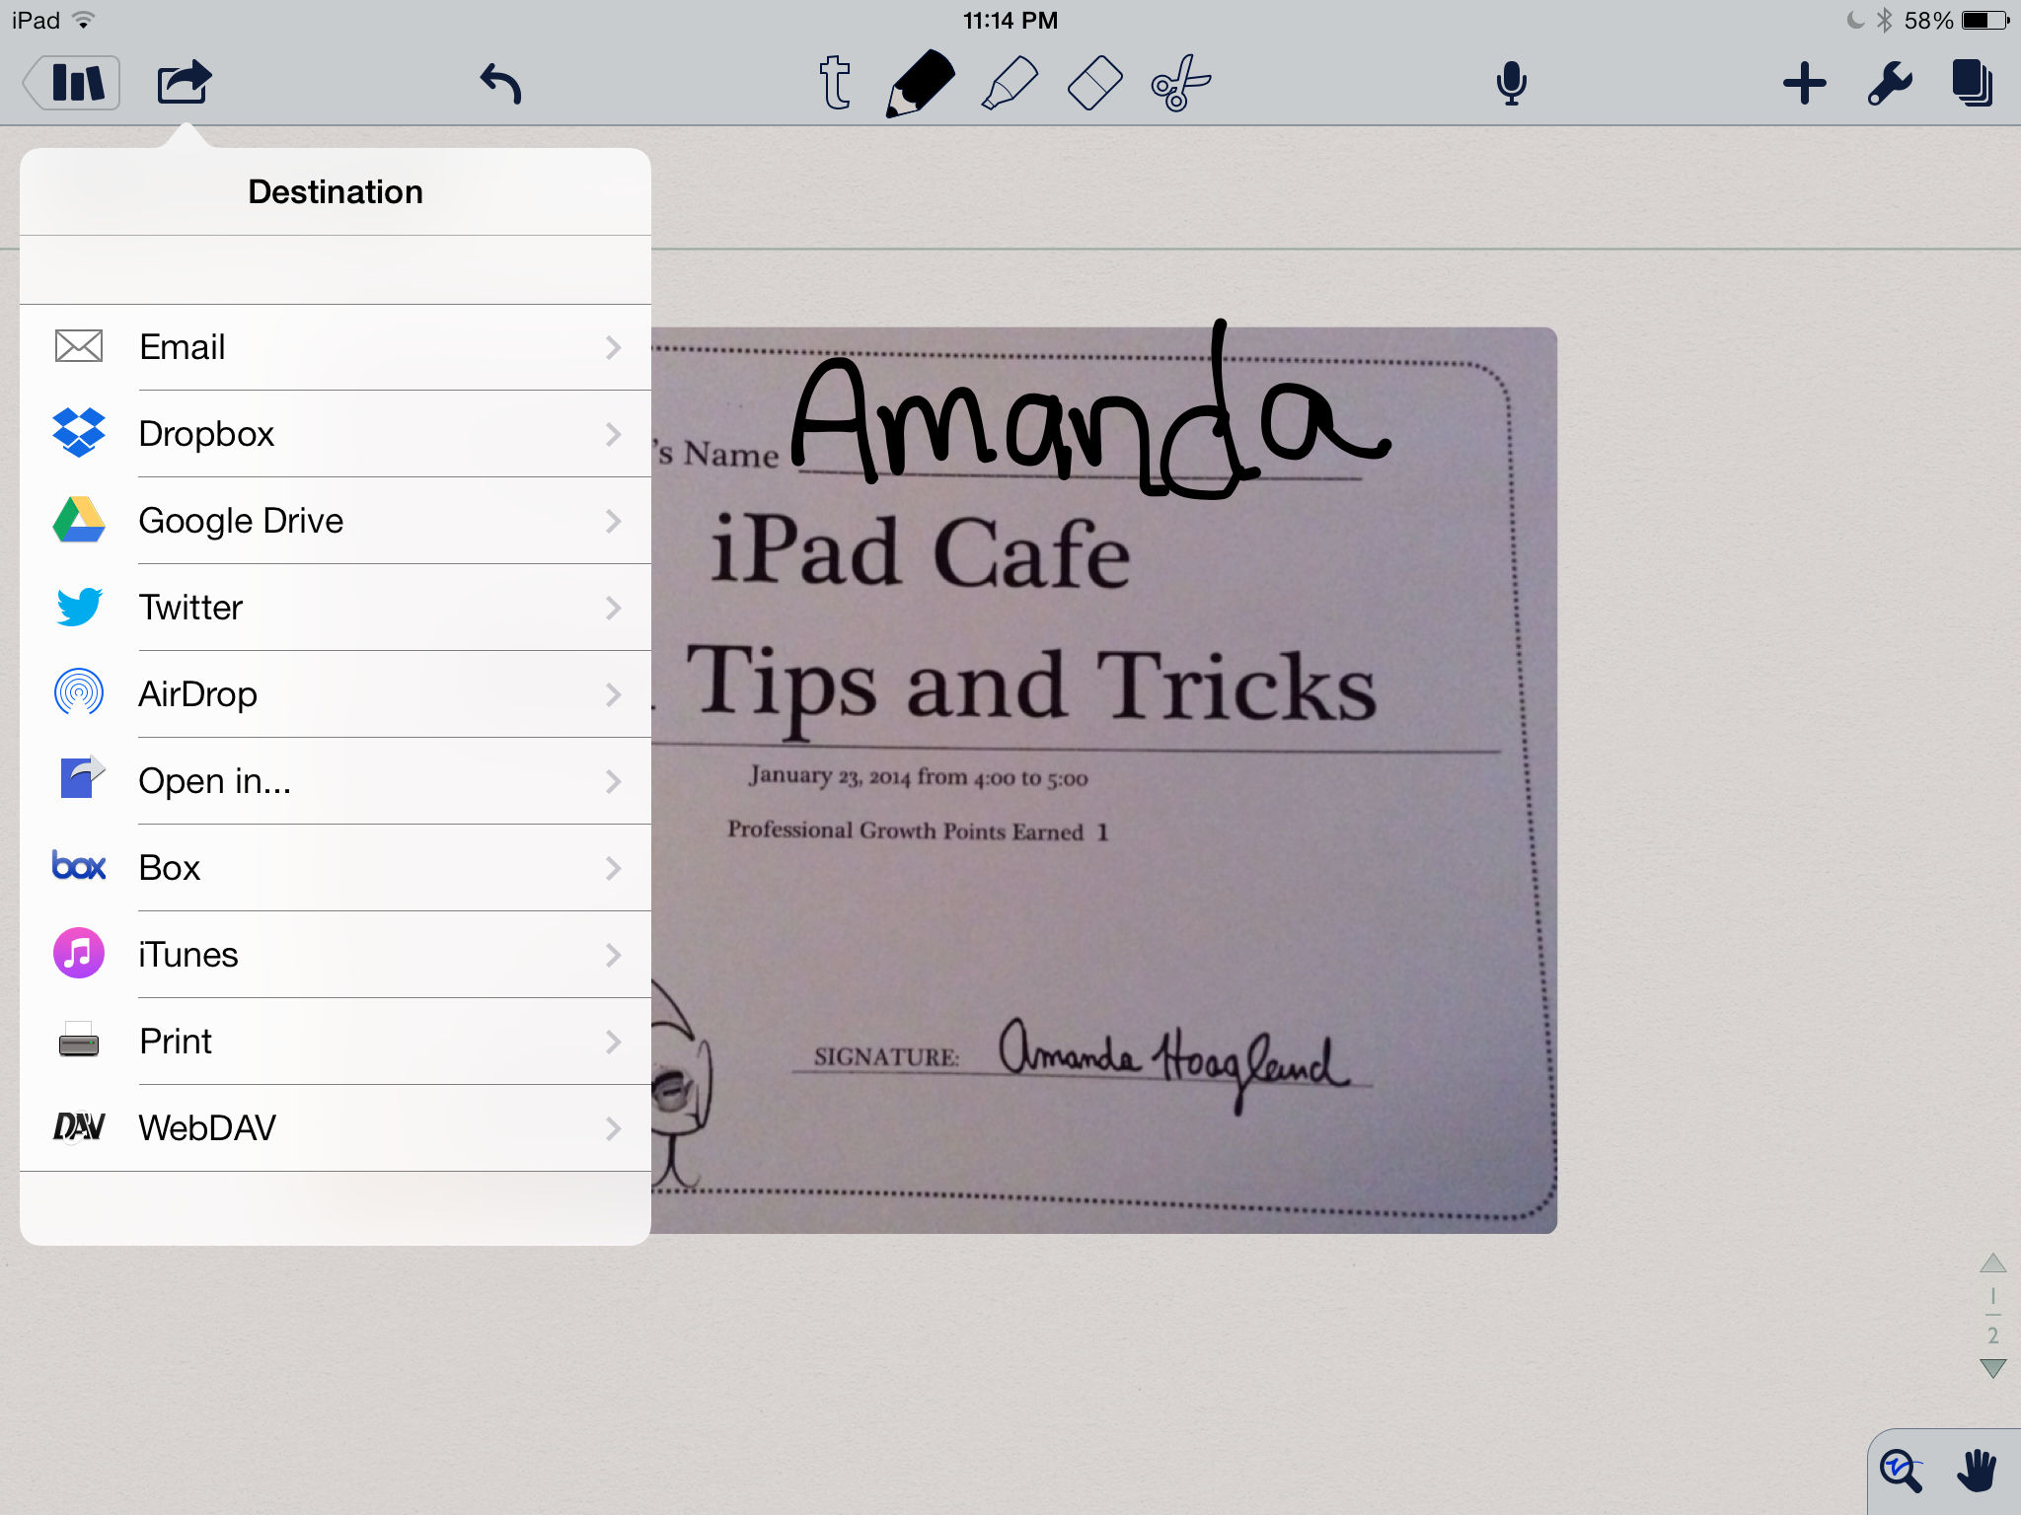

Google Drive

8. Use your Google Drive as a great place to store documents, send assignments, and communicate with your class.

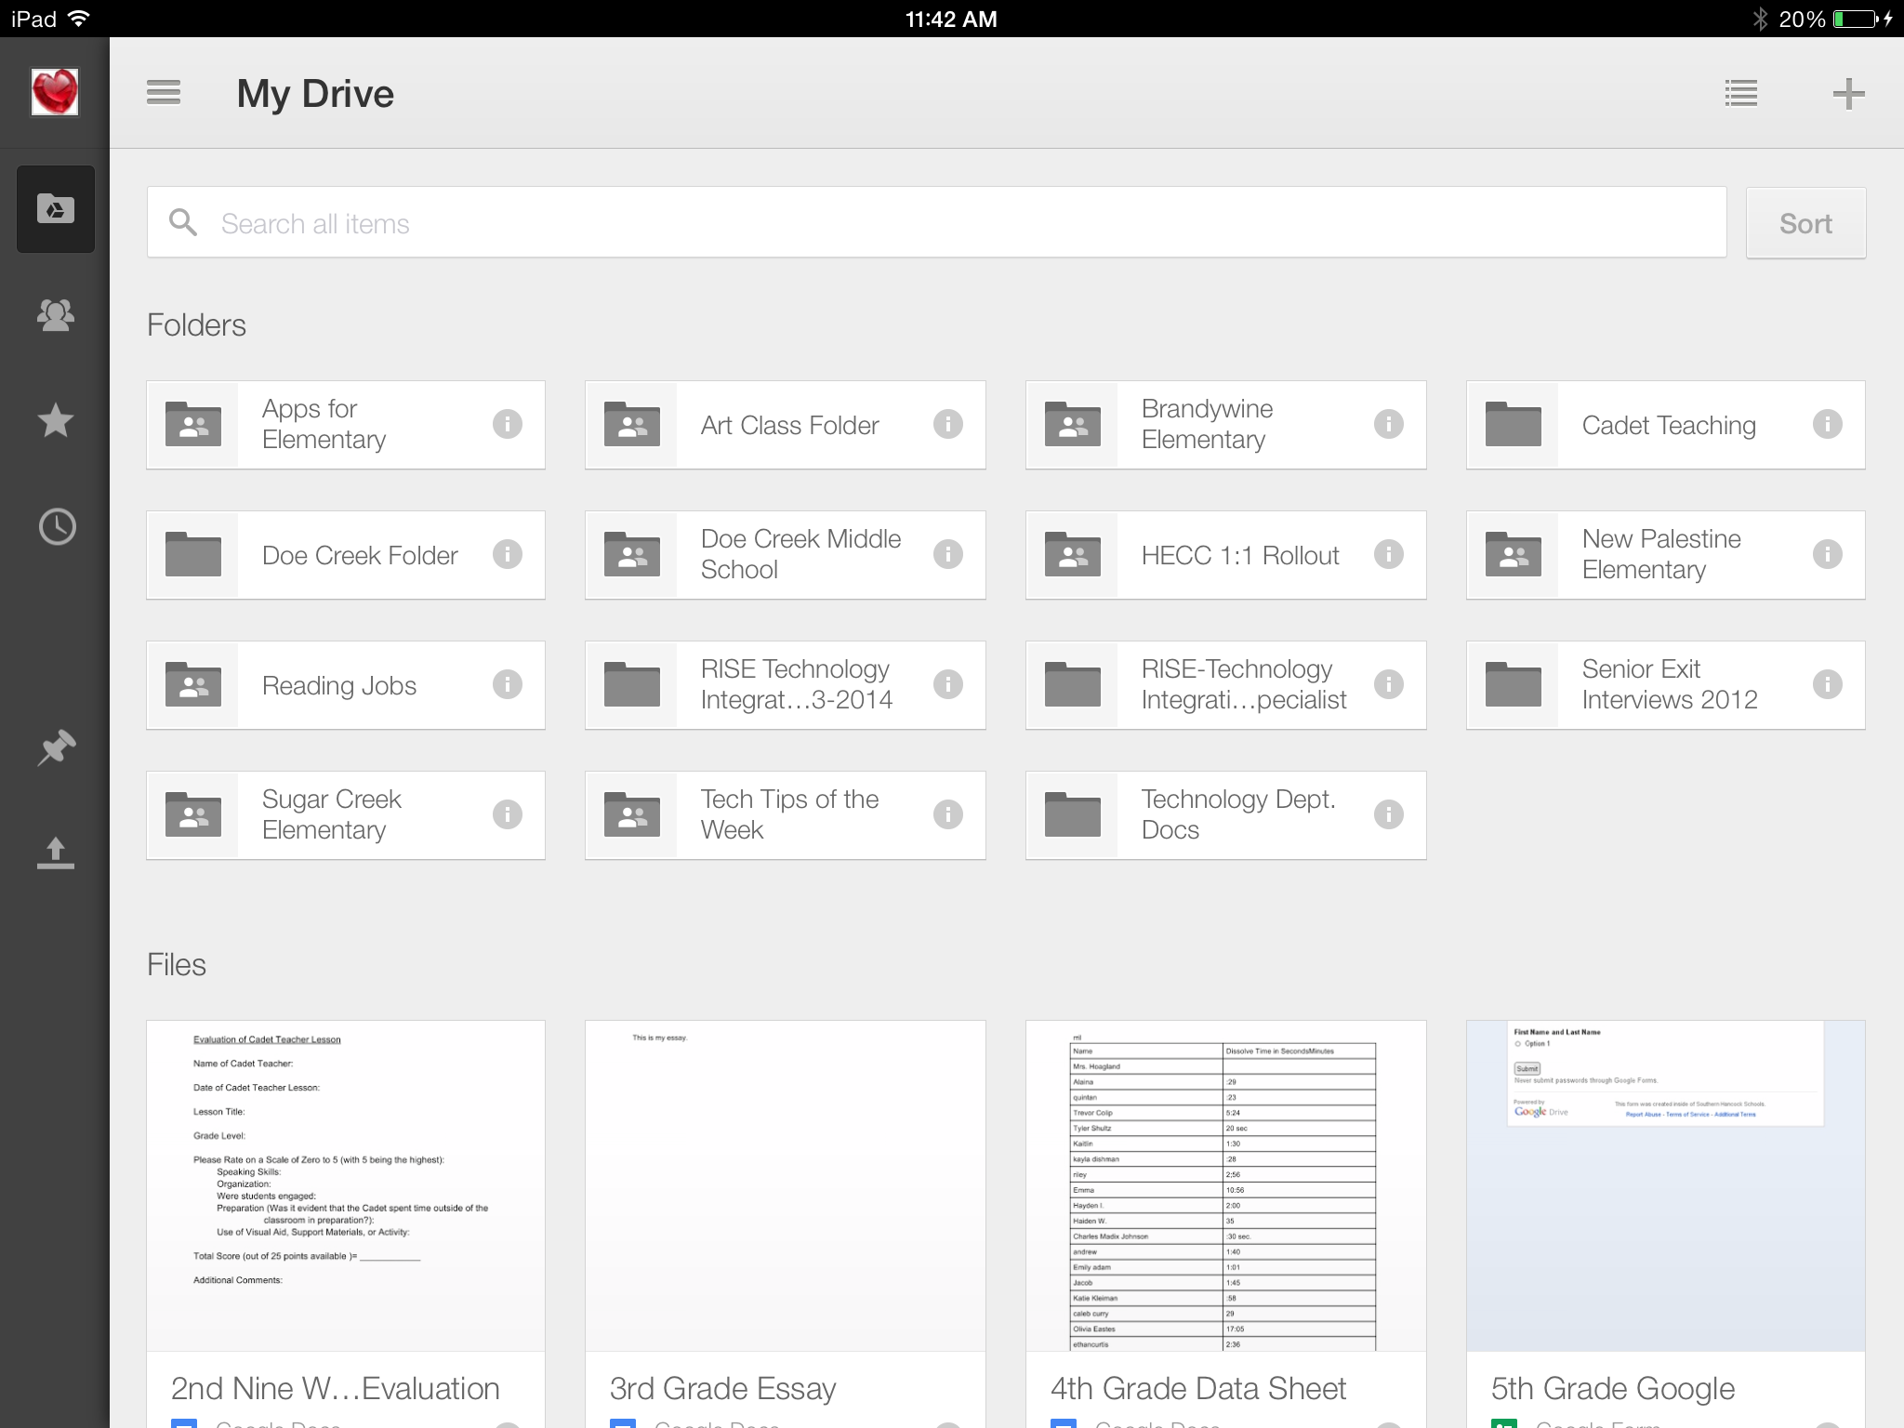
My Drive Contents

Shared with Me

Favorites

Most Recent Documents

Offline

Uploads

Add a New Document, Spreadsheet, or Folder

Upload items from iPad or take a picture.

Share a doc or folder using the info. Button.
