iPad Café
iOS 7
2014
Week #1 iPad Tips, Tricks, and Classroom Workflow

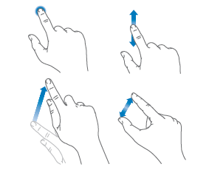

Gestures and Buttons

Tap, Drag, Swipe, and Pinch

Sleep/Wake/Power Button

Hold in Power Button to Power Off
•• Remember to Shut Down on Fridays!!!
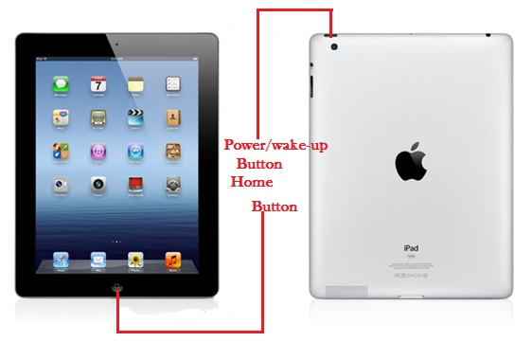
Home Button
Tap Home to Go Back to the Main Screen
Press and Hold the Home Button to Use Siri

ScreenShot
Press the Home Button and Power Button

Close Apps
Double Click the Home Button
Slide Apps Up to Close Them

Side Switch/Volume and Screen Rotation

Screen Rotation

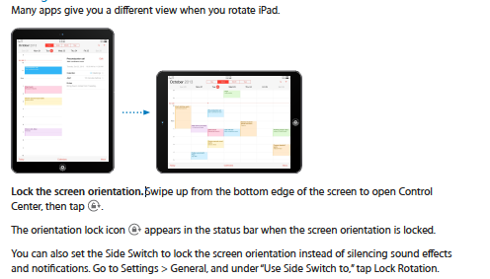

•• You can also use the side switch to MUTE.
•• Volume
Adjust the volume. Press the Volume buttons.
Mute the sound: Press and hold the Volume Down button.

Customize iPad
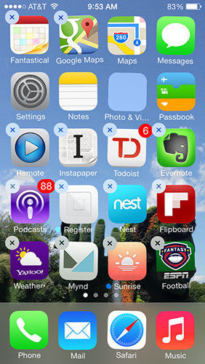

Arrange Your Apps
Touch and Hold Until Apps Jiggle
Drag to Arrange
Tap the X to Delete

App Folders
Drag One App Onto Another to Create a Folder
Tap the Name of the Folder to Name It
Drag Out All of the Apps to Delete a Folder

**Start over. Go to Settings > General > Reset, then tap Reset Home Screen
Layout to return the Home screen and apps to their original layout. Folders are
removed and the original wallpaper is restored.

Wallpapers and Screen Brightness
Go to Settings>Wall Papers & Brightness
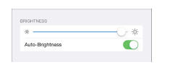
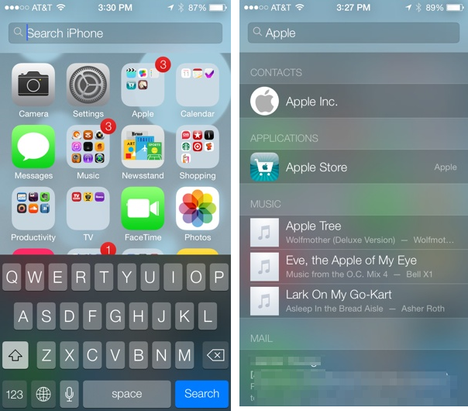

Spotlight
Swipe Down to Find the Spotlight Tool
Type the Name of Any App to Find It
**Find Notes App on iPad

Keyboard
Click Shift for Uppercase
Hide the onscreen keyboard. Tap the Keyboard key.
Tap and Hold Over a Word to Select it or Select All
Tap and Hold to Display Grab Points to Cut, Copy, or Paste
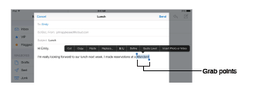

Split Keyboard by Sliding your Finger and Thumb to Split
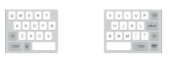

Tired of Typing? Use the for Dictation

Control Center
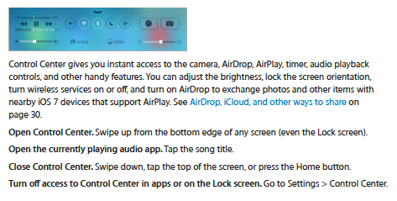

Airplay
Tap to Access AirPlay mirrioring with Nearby Devices

AirDrop
Share Videos, Photos, Websites,etc. with a Nearby iOS 7 Device
Click AirDrop to Change Sharing Options
Tap Share or , then tap AirDrop and tap the name of a nearby AirDrop user

Safari
Enter Your Search and Tap Go or Tap a Suggested Site

Share Button and Tap Add to Homescreen
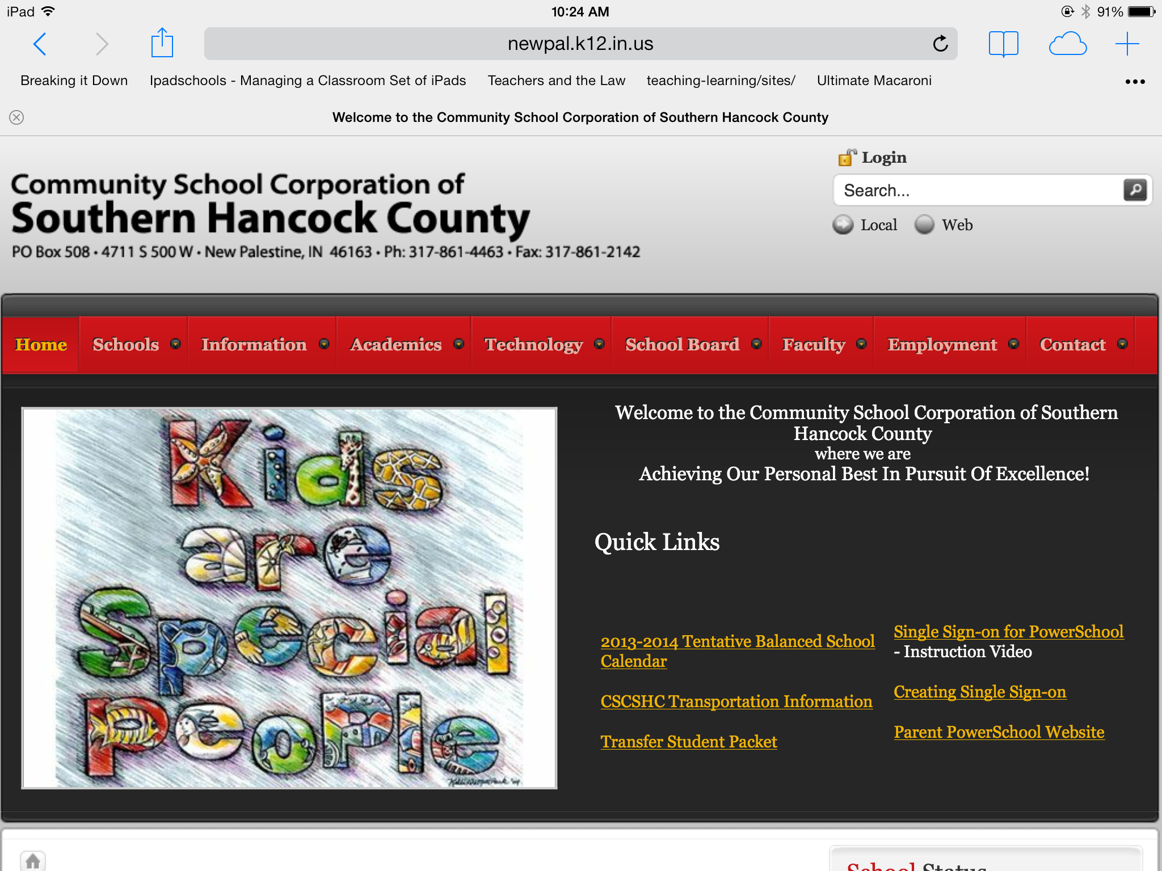
Tap to Print a Document

Refresh Button to Reload a Page 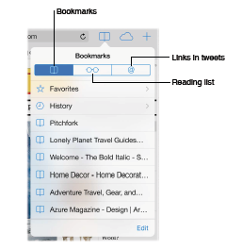

Bookmark Pages You Want to Keep and Even
Add Pages to Your Favorites Screen

iCloud Tab

Add a New Tab to Your Browser to Display Several Web Pages

Access Favorites Quickly

Apps for Classroom Management

Class Dojo
Students and Parents Can Have Access to Progress on the Website http://www.classdojo.com/
Once you have signed up for a free account you can access parent and student enrollment guides.

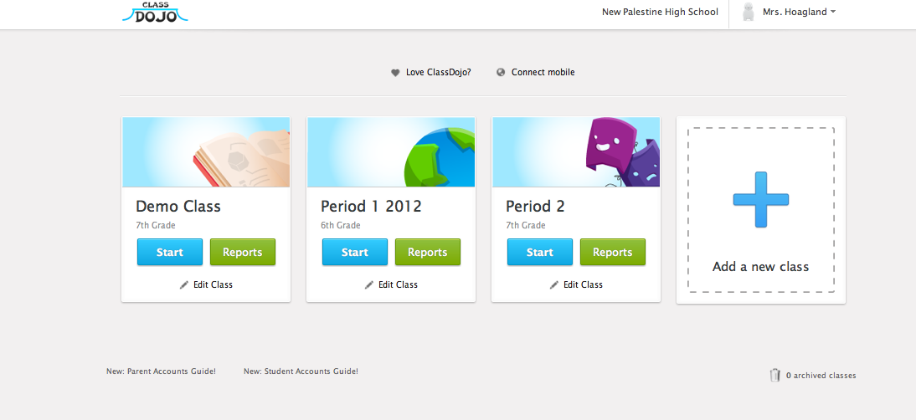

Music Sparkles
Use the chimes to get their attention and sounds for classroom management. Drums and xylophone are free.
Click the Home Button to Return back to this screen shown below.

Too Noisy
Use the gear at the bottom to adjust your settings.
