Accessing netTrekker Using LDAP Authentication
for Students
For the best experience, we recommended using the following web browsers: Google Chrome 35 and above, Mozilla Firefox 35 and above, Microsoft Internet Explorer 10 and 11 or Apple Safari 7 and 8.

Authentication using LDAP is possible by accessing netTrekker directly and using school or district network credentials.
Step 1
Access the netTrekker website directly using https://school.nettrekker.com/login.html?authType=LDAP&ntwCode=HancockCO
Step 2
- In the fields labeled Network Username and Network Password, enter the same credentials that you use on your computer at school.
- The field labeled Network Code should automatically be populated with the value listed below: HancockCO
- Select the button labeled Login.
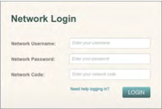

Step 3 (Only required on your first login)
- From the field labeled I belong to, select your school or district.
- From the field labeled I am a, select Student.
- Select the button labeled Continue.
Step 4 (Only required on your first login)
A. Select the button labeled Done.

