Accessing netTrekker Using LDAP Authentication
for Teachers
For the best experience, we recommended using the following web browsers: Google Chrome 35 and above, Mozilla Firefox 35 and above, Microsoft Internet Explorer 10 and 11 or Apple Safari 7 and 8.
Authentication using LDAP is possible by accessing netTrekker directly and using school or district network credentials.
Step 1
Access the netTrekker website directly using
https://school.nettrekker.com/login.html?authType=LDAP&ntwCode=HancockCO
Step 2
- In the fields labeled Network Username and Network Password, enter the same credentials that you use on your computer at school.
- The field labeled Network Code should automatically be populated with the value listed below: HancockCO
- Select the button labeled Login.
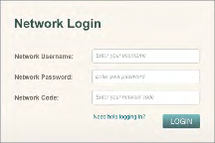
Step 3 (Only required on your first login)
- From the field labeled I belong to, select your school or district.
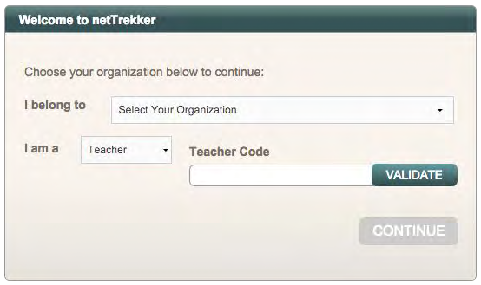
- From the field labeled I am a, select Teacher.
- In the field labeled Teacher Code, enter the value listed below:
dragons3115
- Select the button labeled Validate, and then select the button labeled Continue.
Step 4 (Only required on your first login)
- Select the button labeled Done.
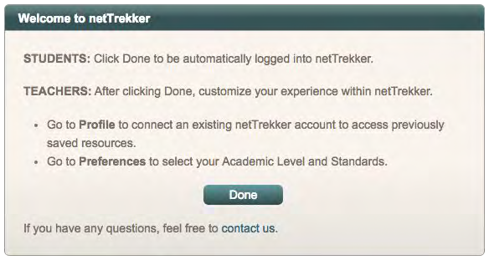
- Thereafter you can customize your experience within netTrekker, such as connecting an existing netTrekker account to access previously saved resources or selecting your Academic Level and Standards.

